三、研究計畫內容（以中文或英文撰寫）：

# 研究計畫之背景。請詳述本研究計畫所要探討或解決的問題、研究原創性、重要性、預期影響性及國內外有關本計畫之研究情況、重要參考文獻之評述等。如為連續性計畫應說明上年度研究進度。

In this research project, we are developing a spatially-reconfigurable phased array (SRPArray) carried by a swarm of unmanned aerial vehicles (UAVs), which are coined SRPCubes in this proposal. The prototype SRPArray will be built for use as relays in aerial networks for 5G and beyond (B5G), as shown in Fig. 1 and Fig. 2. With the aid of the proposed microwave-assisted ultrasonic positioning (MAUP) method, SRPCubes in the SRPArray will be able to synthesize the radiation pattern by changing their relative positions and adjusting the phase delays of the phase shifters. Some exemplary application scenarios are shown in Fig. 3. Note that MAUP is a novel 1D positioning method, which can readily be extended to 2D and 3D positioning, and will be detailed in the later sections. With spatial reconfigurability, SRPArray has great potential to be applied to ground-penetrating radars, high-mobility radars, temporary base stations, etc. In this project, as a proof of concept, the SRPArray will be implemented for use in the multi-tier aerial network for 5G/B5G [1].

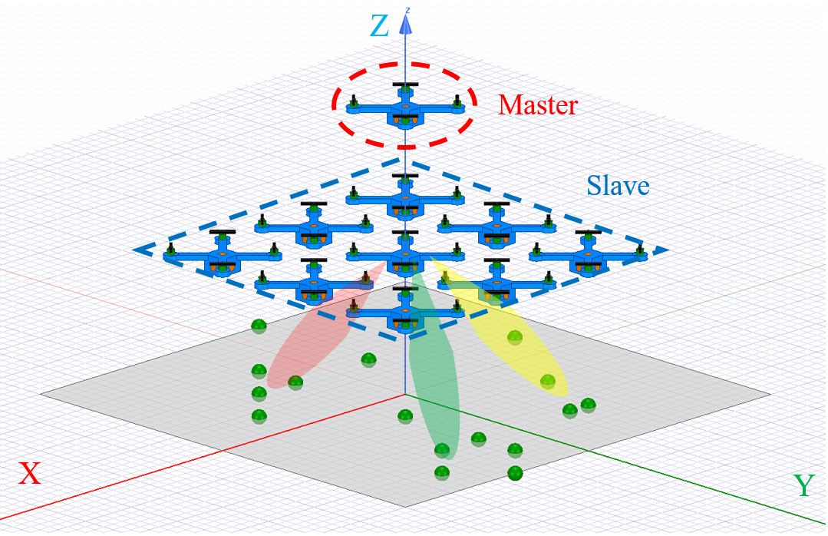

Fig. 1. The proposed SRPArray, composed of one SRPCube in master mode (red dashed line) and multiple SRPCubes in slave mode (blue dashed line), is providing service to users (green spheres) on the ground. The semi-transparent red, yellow, and green areas represent the beams synthesized by the SRPArray.

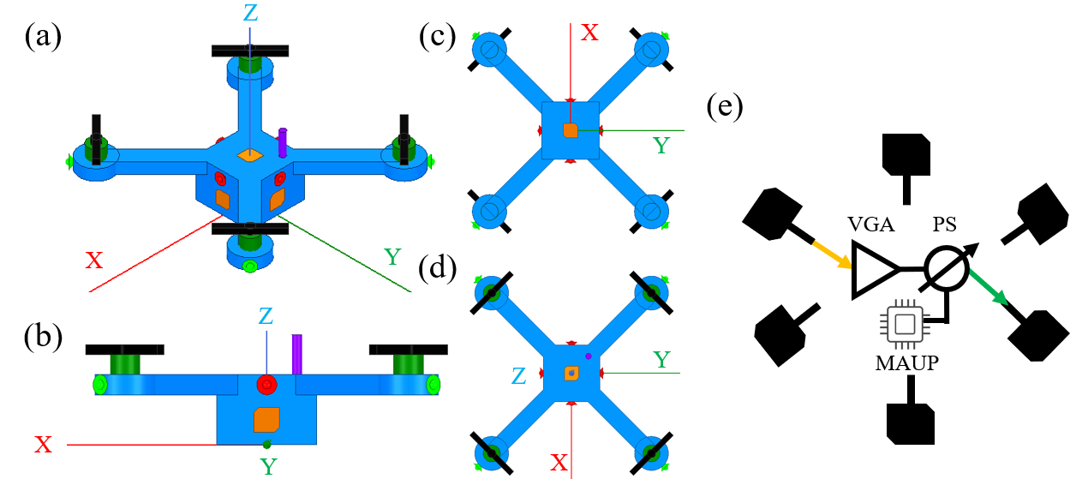

Fig. 2. Overview of a SRPCube. In master mode, the speakers (in red) broadcast ultrasonic signals, and the monopole antenna (in purple) broadcast the positioning radio-frequency (RF) signals. In slave mode, microphones (in light green) receive ultrasonic signals, and the same monopole (in purple) receives the positioning RF signals. The Blue areas represent the plastic body, green cylinders are the motors, black strips are the propellers, and the yellow polygons are the exemplary circularly polarized (CP) patch antennas. (a) Isometric view, (b) side view, (c) bottom view, and (d) top view are shown respectively. (e) Block diagram of the main circuitry in the SRPCube, including six CP-patch antennas, a variable gain amplifier (VGA), a phase shifter (PS), the MAUP circuit, and two switches (yellow and green arrows). The two switches, which would be realized by a six-pole-six-throw (6P6T) RF switch, determine the paths of input (yellow) and output (green) RF signals, and the MAUP circuit provides real-time highly accurate positioning information to PS, ensuring that the radiation pattern of the SRPArray is immune to the disturbance of the SRPCubes’ positions. For complete schematic of the circuits, please refer to Fig. 8.

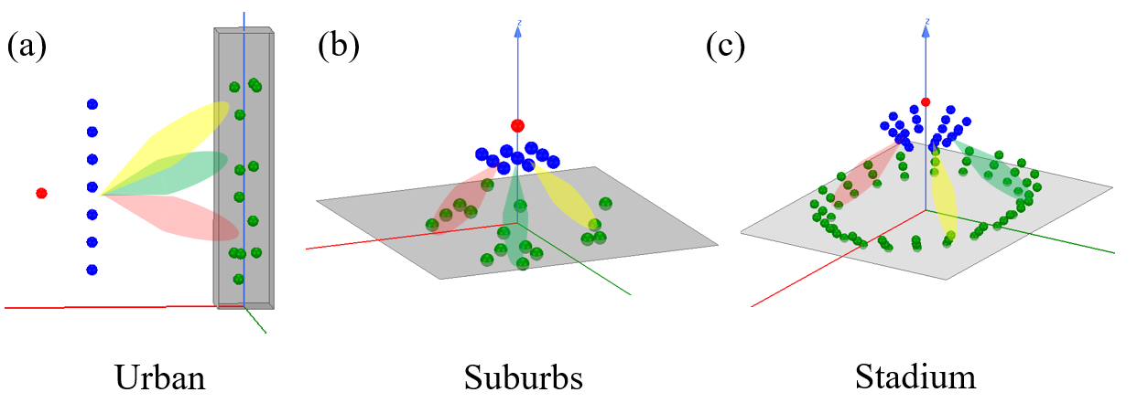

Fig. 3 Exemplary application scenarios of the proposed SRPArray and how the SRPCubes are arranged. The red sphere represents the SRPCube in master mode, and the blue spheres represent the SRPCubes in slave mode. The semi-transparent areas colored in green, red, and yellow represent the scanning beams of the SRPArray. Thanks to the high flexibility and mobility, the SRPArray could adapt its spatial configuration according to the distribution of users.

A multi-tier UAV, or drone, architecture of 5G/B5G cellular network is shown in Fig. 4. Due to the high mobility for on-demand deployment, improved line-of-sight (LoS) environment at high altitude, and low-profile for flying between skyscrapers, UAVs have the potential to fulfill the broadcasting/point-to-point/point-to-multipoint communication requirements of 5G/B5G [1]. However, the size, weight, and power consumption constraints of UAVs limit their communication, computation, and endurance capabilities [2], and thus hinder their development and deployment.

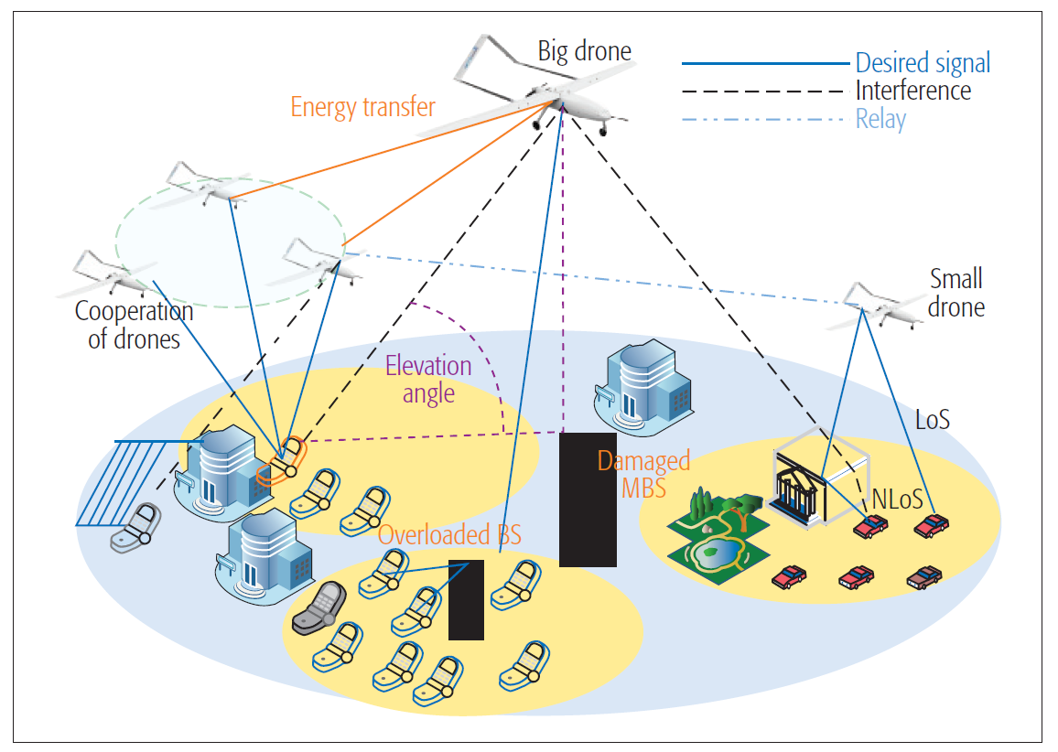

Fig. 4. Drone-assisted network where multiple tiers of drones are used. The drones are connected to terrestrial networks via a satellite link or air-to-ground wireless network [1].

By the altitude at which the aerial wireless communication systems operate, they could be classified into two groups, high-altitude platforms (HAPs) and low-altitude platforms (LAPs). HAPs, such as fixed-wing UAVs or airships operating in the stratosphere, have long endurance, high-capacities, and wide coverage [3], but the path loss is high due to the long distance between base stations (BSs) and user equipment [4]. In contrast, LAPs, typically quadcopters, have higher mobility, provide short-range LoS, and are far more cost-effective, but LAPs could only support payloads of very-limited weight (up to a few kilograms) and operate for a limited duration (up to one hour) [2].

The proposed SRPArray is dedicated to alleviating the aforementioned constraints on LAPs. A SRPArray, composed of a swarm of synchronized SRPCubes as shown in Fig. 2, is a phased array with spatial reconfigurability. With antenna elements separately carried by SRPCubes, the SRPArray could adaptively deploy a phased array with an aperture much larger than the size of a single quadcopter. The larger aperture of the phased array implies narrower beamwidth and better spectrum efficiency. Furthermore, since all SRPCubes are identical and could operate independently, their batteries could be recharged individually without the need to shut down the service of the entire SRPArray. Last but not least, thanks to the spatial reconfigurability, the SRPArray could adaptively reconfigure itself to accommodate the ever-changing distribution of potential users and then form the beam(s) to targeted user(s) when needed so that the quality of communication is optimized and the power consumption for RF transmission is minimized.

Fig. 3 shows some exemplary application scenarios of SRPArray along with the corresponding main beam directions and spatial arrangements of the SRPCubes. In each case, only one SRPCube is operating in master mode, serving as a reference point of the SRPArray and broadcasting signals, and the other SRPCubes operate in slave mode and serve as wireless relays that perform beamforming with the signal received from the master SRPCube. When used in urban areas as shown in Fig. 3(a), since users tend to stay in skyscrapers, the vertically-distributed SRPCubes could provide better angular resolution of beam-scanning along the vertical direction. When used in suburbs as shown in Fig. 3(b), since users scatter around horizontally with minimal vertical blockage compared to urban area, it is straightforward to keep the SRPCubes high and distributed horizontally. When used in a stadium as shown in Fig. 3(c), since the spectators are distributed on the periphery of the stadium, SRPCubes could be arranged into, say a circular array, concentrating the radiation power to the spectators instead of the center stage. Also, more complicated distributions of SRPCubes could readily be realized if the prediction of user behavior [5] and the modeling of the blockage and attenuation of radiation-frequency (RF) signal [6] are taken into account.

While from different perspective, a concept similar to the spatially reconfigurable antenna array has been proved feasible in 2003, when H. Schippers et al. proposed a radiation analysis of conformal phased array antennas on distorted structures [7]. It was shown that the array pattern could be obtained by analyzing the equivalent current of antenna elements, as shown in Fig. 5. In 2013, D. Braaten et al. used a flexible resistive sensor to measure the surface deformation of a 1×4 antenna array and phase shifters to provide phase compensation to each element of the array, as shown in Fig. 6 [8]. The results shown in Fig. 7 proved that the effect of deformation could be corrected once accurate displacement of antenna elements is known. It is thus believed that once the positions of SRPCubes are acquired with sufficient accuracy, which will be realized via our proposed MAUP method, a highly-directive and accurate beam can then be formed by the SRPArray.

The specifications of the 1D positioning method, namely the proposed MAUP method, for the SRPArray include: (1) updating rate faster than 10 Hz, (2) range resolution better than 0.1 wavelength, which is about 8.6 mm at 3.5 GHz, and (3) well function even with non-LoS. The updating rate is set to better compensate the drifting caused by a gust of wind and also to ensure quasi-real-time beam tracking, the range resolution is set to ensure the positioning accuracy and hence the quality of beamforming, and the non-LoS requirement is included because the SRPCubes might block each other when forming an optimum radiation pattern. Referring to the specifications and the systems mentioned in [9] and [10] , the MAUP method is proposed in this proposal and verified by our preliminary experiments to be able to reach an accuracy of about 15.3-mm along with at least 1-meter detection range. Although the desired range resolution is not yet achieved, the proposed MAUP method shows great potential to be improved to fulfill the needs of the SRPArray.

All in all, beam-steerable high-gain and highly flexible antenna array has been needed in 5G/B5G system, and the proposed SRPArray is promising to serve as relays and meet the requirements according to the results of the previous works and the proposed microwave-assisted ultrasonic positioning (MAUP) method.

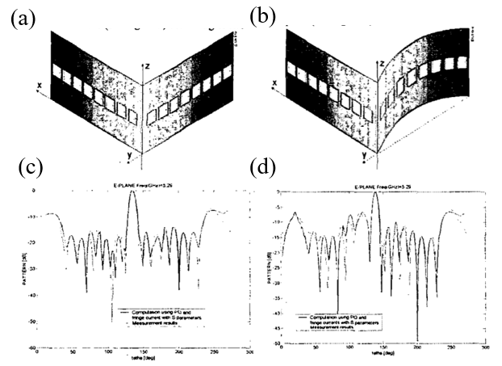

Fig. 5. C-Band phased array on (a) a non-deformed and (b) a deformed corner structure. The radiation patterns obtained from measurement and analysis of (c) the non-deformed and (d) the deformed corner structure [7].

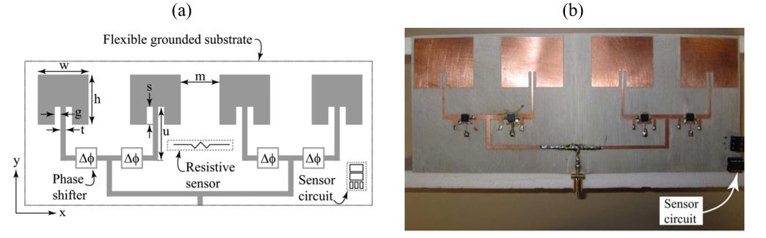

Fig. 6. (a) Schematic and (b) photograph of SELFLEX antenna array [8].

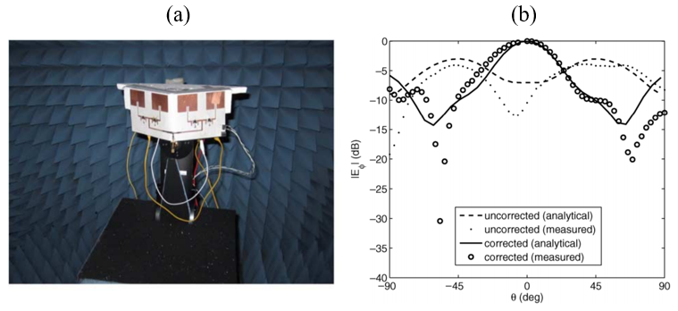

Fig. 7. (a) Photograph of the 1×4 antenna array attached to a non-conducting 90° wedge. (b) Measured and analytical radiation patterns with and without phase correction [8].

**References**

[1] S. Sekander, H. Tabassum, and E. Hossain, “Multi-Tier Drone Architecture for 5G/B5G Cellular Networks: Challenges, Trends, and Prospects,” *IEEE Commun. Mag.*, vol. 56, no. 3, pp. 96–103, Mar. 2018, doi: 10.1109/MCOM.2018.1700666.

[2] Y. Zeng, R. Zhang, and T. J. Lim, “Wireless communications with unmanned aerial vehicles: opportunities and challenges,” *IEEE Commun. Mag.*, vol. 54, no. 5, pp. 36–42, May 2016, doi: 10.1109/MCOM.2016.7470933.

[3] T. C. Tozer and D. Grace, “High-altitude platforms for wireless communications,” *Electron. Commun. Eng. J.*, vol. 13, no. 3, pp. 127–137, Jun. 2001, doi: 10.1049/ecej:20010303.

[4] B. Li, Z. Fei, and Y. Zhang, “UAV Communications for 5G and Beyond: Recent Advances and Future Trends,” *IEEE Internet Things J.*, vol. 6, no. 2, pp. 2241–2263, Apr. 2019, doi: 10.1109/JIOT.2018.2887086.

[5] A. Al-Hourani, S. Kandeepan, and A. Jamalipour, “Modeling air-to-ground path loss for low altitude platforms in urban environments,” in *2014 IEEE Global Communications Conference*, Dec. 2014, pp. 2898–2904, doi: 10.1109/GLOCOM.2014.7037248.

[6] M. Mozaffari, W. Saad, M. Bennis, and M. Debbah, “Efficient Deployment of Multiple Unmanned Aerial Vehicles for Optimal Wireless Coverage,” *IEEE Commun. Lett.*, vol. 20, no. 8, pp. 1647–1650, Aug. 2016, doi: 10.1109/LCOMM.2016.2578312.

[7] H. Schippers, G. Spalluto, and G. Vos, “Radiation analysis of conformal phased array antennas on distorted structures,” in *Twelfth International Conference on Antennas and Propagation, 2003 (ICAP 2003). (Conf. Publ. No. 491)*, Mar. 2003, vol. 1, pp. 160–163 vol.1, doi: 10.1049/cp:20030040.

[8] B. D. Braaten *et al.*, “A Self-Adapting Flexible (SELFLEX) Antenna Array for Changing Conformal Surface Applications,” *IEEE Trans. Antennas Propag.*, vol. 61, no. 2, pp. 655–665, Feb. 2013, doi: 10.1109/TAP.2012.2226227.

[9] F. Zafari, A. Gkelias, and K. K. Leung, “A Survey of Indoor Localization Systems and Technologies,” *IEEE Commun. Surv. Tutor.*, vol. 21, no. 3, pp. 2568–2599, thirdquarter 2019, doi: 10.1109/COMST.2019.2911558.

[10] L. Mainetti, L. Patrono, and I. Sergi, “A survey on indoor positioning systems,” in *2014 22nd International Conference on Software, Telecommunications and Computer Networks (SoftCOM)*, Sep. 2014, pp. 111–120, doi: 10.1109/SOFTCOM.2014.7039067.

[11] H. Liu, H. Darabi, P. Banerjee, and J. Liu, “Survey of Wireless Indoor Positioning Techniques and Systems,” *IEEE Trans. Syst. Man Cybern. Part C Appl. Rev.*, vol. 37, no. 6, pp. 1067–1080, Nov. 2007, doi: 10.1109/TSMCC.2007.905750.

# 研究方法、進行步驟及執行進度。請分年列述：1. 本計畫採用之研究方法與原因及其創新性。2. 預計可能遭遇之困難及解決途徑 。3. 重要儀器之配合使用情形。4. 如為須赴國外或大陸地區研究，請詳述其必要性以及預期效益等。

The two key parts of the proposed SRPArray are the positioning subsystem and the beamforming subsystem. As already shown in Fig. 1, a SRPArray is composed of a SRPCube in master mode, which serves as the RF signal source and reference point for positioning, and multiple SRPCubes in slave mode, which are amplitude- and phase-adjustable relays for synthesizing the total pattern. The schematic of the SRPCube circuit is depicted in Fig. 8.

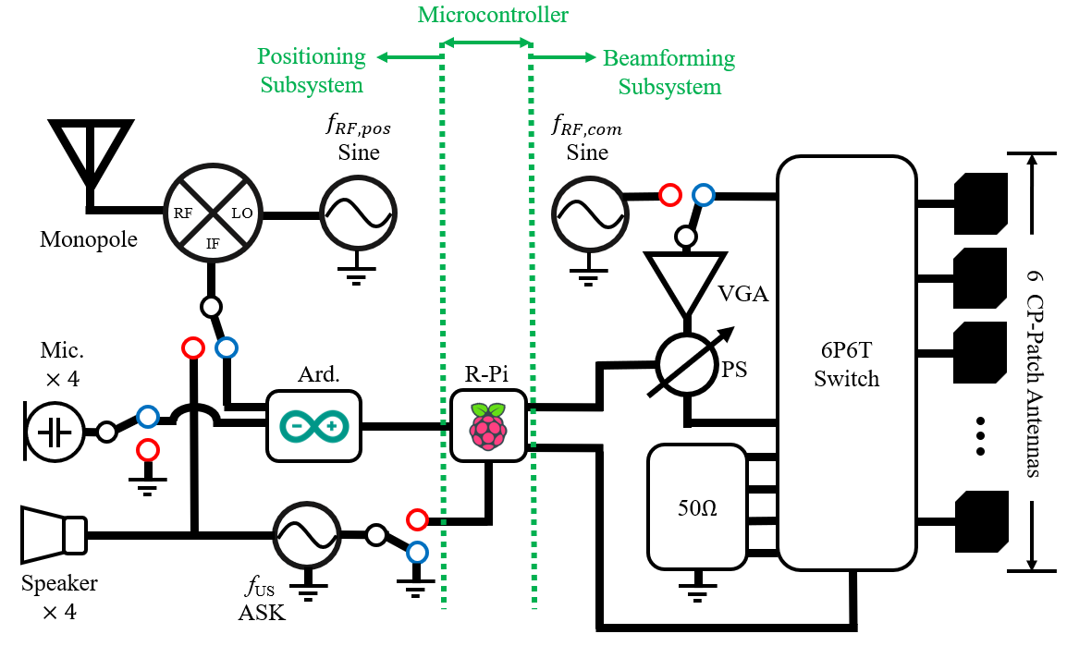

Fig. 8. Schematic of a SRPCube circuit, in which all components and switches are controlled by a Raspberry Pi board (R-Pi). The switches will be set to red dots for master mode operation and to blue dots for slave mode operation. The switch states shown here is in slave mode. In the positioning subsystem, there are two voltage sources, a continuous-wave (CW) source centered at frequency *f*RF,pos and an amplitude-shift-keying (ASK) source centered at frequency *f*US. And an Arduino board (Ard) serves as an analog-to-digital converter (ADC) for sampling the positioning signals. In the beamforming subsystem, the input port of the VGA is fed by either a *f*RF,com voltage source or a CP-patch antenna through the six-pole-six-throw (6P6T) switch, and the phase shifter (PS) at the VGA’s output port performs phase compensation on the signal. Then, the signal is transferred to one of the CP-patch antennas via the 6P6T switch. The input/output CP-patch antennas could be arbitrarily selected by the 6P6T RF switch.

Two signal sources centered respectively at *f*RF,pos and *f*US are used in MAUP for positioning, which will be discussed later. As for the signal source centered at *f*RF,com, it is used merely to mimic the modulated RF signals for communication service, which will be transmitted via the array beam to be synthesized. When the SRPCube is set in master mode, the monopole antenna and the speakers of the master SRPCube will broadcast the positioning signals, and one of the CP-patch antennas on the master SRPCube will transmits the RF signals from the signal source at *f*RF,com to the other slave SRPCubes, which serve as amplitude- and phase-adjustable relays. After receiving the positioning signals from the master SRPCube, the slave SRPCubes will perform a series of positioning calculation (to be discussed later) to acquire their own relative positions from the master SRPCube, apply proper phase and amplitude compensation to the received *f*RF,com signal, and transmit it via another CP-patch antenna. As a result, the array pattern of the SRPArray is formed by the phasing signals transmitted from the slave SRPCubes.

Next, in Section I, the specification, design, positioning algorithm, and some preliminary test results of the proposed MAUP positioning subsystem will be detailed. In Section II, the algorithm for phase compensation will be introduced, followed by an experimental setup for verification. In Section III, both simulation and measurement methods for characterizing the radiation patterns of the SRPArray are discussed. The simulation results have shown that MAUP is accurate enough so that the SRPArray could form a satisfactory array pattern in real time.

1. Positioning Subsystem

Specifications

The performance of positioning subsystem plays a crucial role in the proposed SRPArray. The specifications listed in Table 1 must be met in order to synthesize a stable beam as required by the SRPArray.

The positioning accuracy is determined by the wavelength of the communication RF signal centered at *f*RF,com. As shown in Fig. 9, the spectrum around 3.5 GHz is widely-adopted internationally for 5G/B5G. Here, the specification of positioning accuracy is set at 0.1*λ*, which is approximately 8.6 mm. Because the working environment of SRPCubes in flight is highly dynamic, the response time must be much shorter than 1 sec, and in our case, we chose 0.1 sec for preliminary study. It should definitely be improved. Also, note that the positioning method must function as well even under non-LoS conditions; otherwise, the total number of SRPCubes that can be used in a SRPArray and their spatial arrangement will be greatly limited. Considering that the SRPArray would be deployed near the users, we set the RF bandwidth of the positioning signal (*f*RF,pos) to be narrower than 1 MHz to avoid interference to users.

The maximum detection range of the positioning subsystem is determined by the maximum inter-SRPCube spacing in the SRPArray, which is mainly determined by the desired peak gain of the overall antenna array. For instance, if we want to achieve a phased array with a peak gain of about 20 dBi, according to the relation between gain and physical aperture of the array: , where is the physical aperture of the array, *R* is the radius of the array aperture, *G* is the gain of the array, *λ* is the wavelength of the communication RF signal (*f*RF,com), and *ea* is the aperture efficiency. By assuming that *ea* = 0.1, we have *R* = 0.43 m. Because the maximum inter-SRPCube spacing occurs between the master SRPCube and those in slave mode placed at the outer rim of the entire array, here, we set the maximum detection range to be 1 m.

The aforementioned requirements of positioning accuracy and maximum detection range are similar to those for indoor positioning methods. Table 2 summarized the performance and requirements of existing technologies for indoor positioning. Vision and infrared solutions are discarded due to their requirements of LoS. Moreover, Wi-Fi, Bluetooth, and radio-frequency identification (RFID) based solutions are abandoned because of their insufficient accuracy. Ultra-wideband (UWB) techniques are not considered due to the requirement of very wide bandwidth.

Therefore, in this project, we proposed a microwave-assisted ultrasonic positioning (MAUP) method that exploits both RF and ultrasonic signals as the medium of positioning and can fulfill the requirements mentioned above.

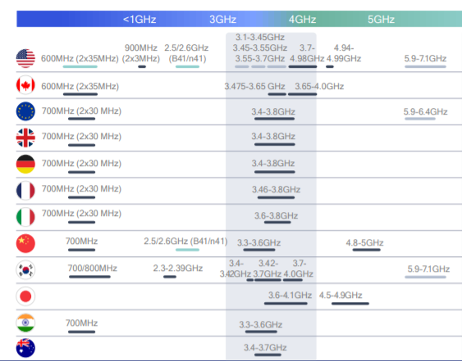

Fig. 9. Sub-6 GHz spectrum for 5G communication. Note that the frequency band around 3.5 GHz is the most widely-adopted sub-6 GHz 5G spectrum. (<https://www.qualcomm.com/media/documents/files/spectrum-for-4g-and-5g.pdf>).

Table 1. Specifications for 1D Positioning in the Proposed SRPArray.

|  |  |  |  |  |
| --- | --- | --- | --- | --- |
| Accuracy | Response Time | Require LoS | RF Bandwidth | Max. Range |
| 8.6 mm | 0.1 sec | No | < 1 MHz | 1 m |

Table 2. Comparison of Indoor Positioning Technologies [9], [10].

|  |  |  |  |  |
| --- | --- | --- | --- | --- |
| Methods | Accuracy (m) | Response Time | Require LoS | RF Bandwidth |
| Vision | 10-3 | Long | Yes | n/a |
| Infrared | 10-2 | Short | Yes | n/a |
| Ultrasound | 10-2 | Short | n/a | n/a |
| Wi-Fi (RSSI) | Sub-meter | Long | No | Narrow band |
| Bluetooth (RSSI) | Sub-meter | Long | No | Narrow band |
| RFID | 10-1 | Long | No | Narrow band |
| UWB | 10-1-10-2 | Long | No | > 1 GHz |

Microwave-Assisted Ultrasonic Positioning (MAUP)

MAUP is the proposed triangulation-based positioning subsystem under master/slave scheme. The diagram of MAUP is illustrated in Fig. 10. The master SRPCube simultaneously broadcasts two positioning signals, including RF signal *fRF,pos* and ultrasonic signal *fUS*. In the meantime, multiple SRPCubes locate themselves by calculating the time difference between the arrival of *fRF,pos* (RF) and *fUS* (ultrasonic) signals. Under such a scheme, the workload of positioning calculation is shared by slave SRPCubes, and thus the response time of positioning is independent of the number of SRPCubes, ensuring the scalability of the SRPArray.

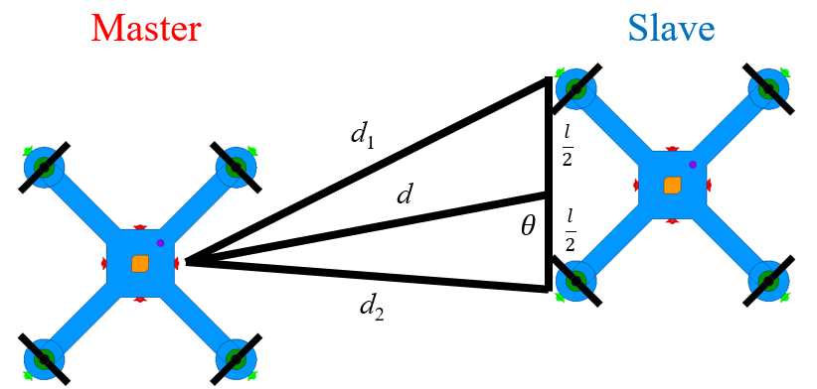

Fig. 10. Diagram of 2D positioning subsystem of MAUP for SRPArray. Four speakers, colored in red, are arranged to simulate an omnidirectional ultrasonic signal source. Four microphones, colored in light green, are separated far on the four arms of SRPCube to ensure better range and angular resolution. The distance *d* and angle *θ* define the relative position between the master and slave SRPCubes. The distances *d*1 and *d*2 can be characterized directly by MAUP. The spacing between the two speakers *l* are fixed and known from the drone design.

MAUP circuit module

The schematic of the proposed MAUP module is depicted in Fig. 11. Two types of signal sources are needed on a master SRPCube, including a CW RF signal source centered at *f­RF,pos* and an amplitude-shift-keying (ASK) ultrasonic source centered at *f*US.Part of the ASK *f*US signal is transmitted by the speakers, and the other is connected to the IF port of a mixer, modulated by the CW RF source at *f*RF,pos, and then broadcasted by the monopole antenna mounted on the master SRPCube, denoted as AM. By calculating the time difference between the arrival of the positioning RF signal (*f­RF,pos*) and the ultrasonic signal (*f*US), each slave SRPCube could obtain the distance between the master SRPCube and itself. To illustrate the proposed MAUP method by the time waveforms of the positioning signals, an experiment was setup as shown in Fig. 12, and the measured spectrograms of *VASK*, *VIF*, and *VMIC* are plotted in Fig. 13. One can see that when the spacing between the master SRPCube (replaced by a box with its front face attached with a speaker and transmitting antenna) and slave SRPCube (replaced by another box attached with a microphone and receiving antenna) is set to zero, the waveforms align with each other. When the spacing is increased to say 50 cm, the lag of the time waveform of the ultrasonic signal *VMIC* is noticeable. For easy comparison, Fig. 14 plots the measured time lagging, or traveling time, versus the spacing along with the theoretical values. Because in theory the traveling time of RF signal is much shorter than the ultrasonic signal, the arrival time difference *tdiff* between them could be obtained by *tdiff* = , where *D* is the spacing between the master and slave SRPCubes and *vS* = 346.45 m/s is the speed of sound at 25°C. Obviously, the measured results agree well with the theoretical traveling time of the ultrasonic signal. By calculating the root-mean-square error between the measured and theoretical results, one can see that MAUP has reached an accuracy of 15.3 mm in 1-D positioning problem.

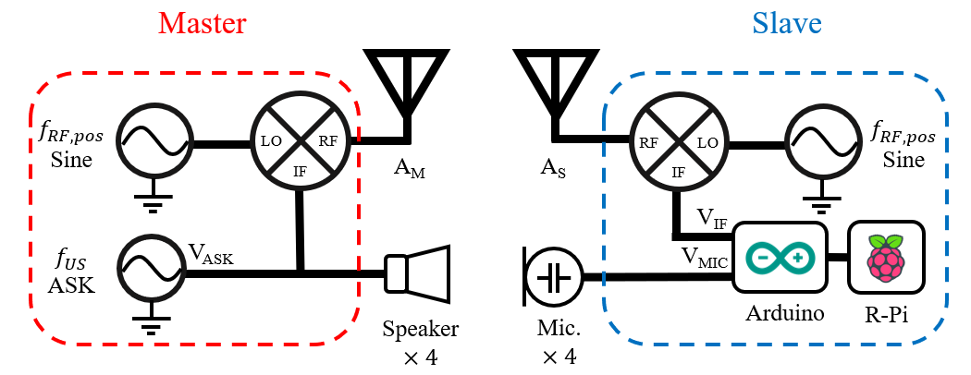

Fig. 11. Block diagram of MAUP module. The master SRPCube broadcasts *f*RF,pos and *f*US signals to the slave SRPCubes. Four microphones (Mic) on slave SRPCubes, each of which could perform distance measurement independently, would help acquire the information of their relative positions from master SRPCube.

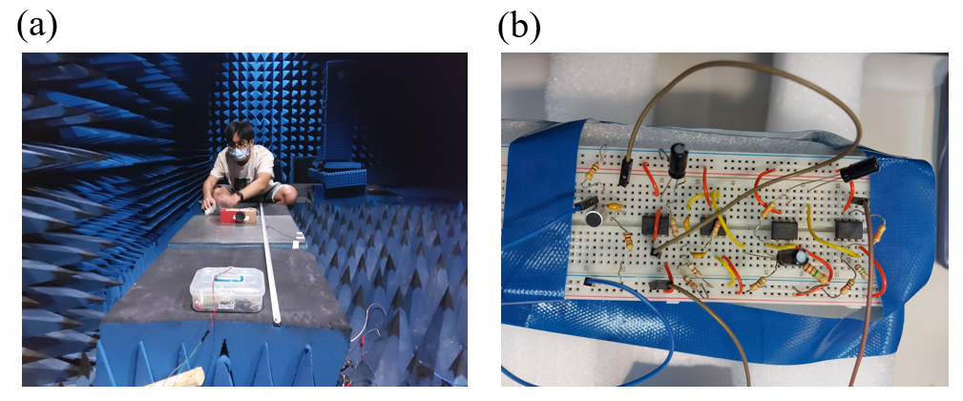

Fig. 12. (a) Photograph of the preliminary experimental setup for distance measurement. The speaker is placed at the far end and attached to a cardboard box. It broadcasts an ultrasonic ASK signal to the microphone, which is placed at the near end and attached to a plastic box. (b) Photograph of the amplification circuits of the microphone used in the experiment. It will be redesigned and refined in the project. Importantly, the precision of the experimental setup could be further improved by using a motorized sliding rail to accurately locate the speaker.

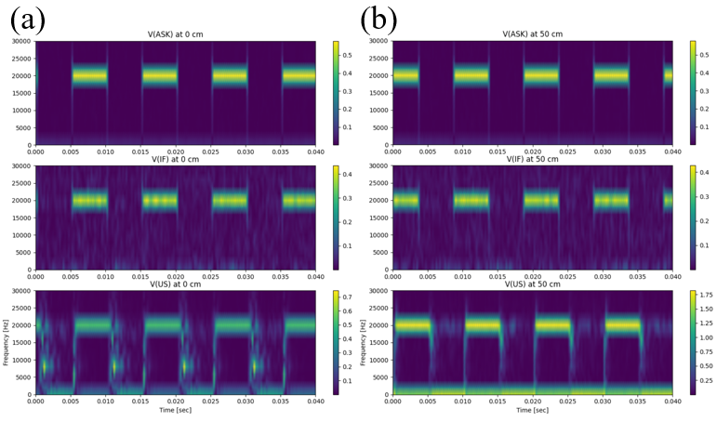

Fig. 13. Spectrograms of normalized voltages of *VASK*, *VIF*, and *VUS* when the distance between the master and slave SRPCubes is (a) 0 cm and (b) 50 cm. (a) shows that the waveforms in all three spectrograms are well aligned. It is simply because the traveling time for both the RF and ultrasonic signals is zero, and hence no time difference. As can be seen from (b), *VUS* lags behind *VASK* and *VIF* noticeably because the ultrasonic signal needs more than 1 ms to travel over the 50-cm distance. For the relationship between the time-delay and distance, please refer to the results plotted in Fig. 14.

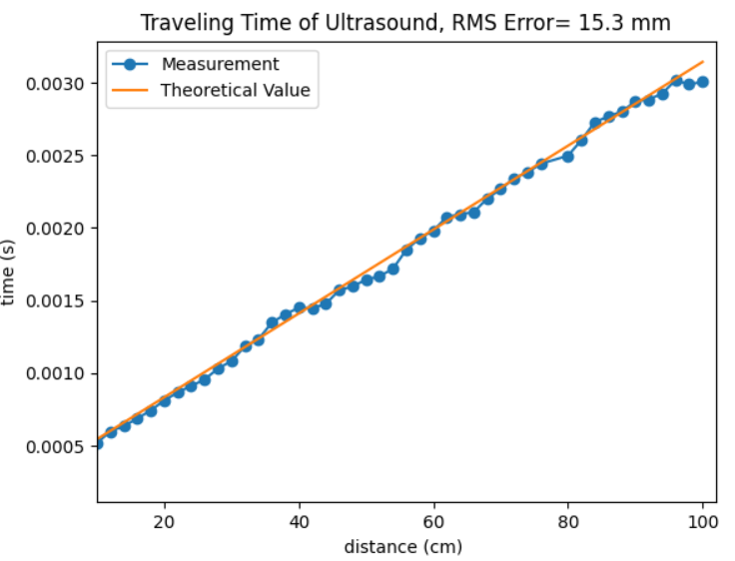

Fig. 14. Preliminary experimental results of our proposed MAUP method. The theoretical speed of sound of 346.45 m/s is adopted. The results show that the root-mean-squared error of the distance measurement is only 15.3 mm.

Positioning Algorithm of 2D MAUP

With four microphones mounted onto each SRPCube and with the aid of a proper positioning algorithm, the slave SRPCube can obtain its relative position from the master SRPCube. Four common positioning techniques are listed in Table 3 for comparison.

Table 3. Properties of Existing Triangulation Positioning Techniques [11].

|  |  |  |
| --- | --- | --- |
| **Type** | **Description** | **Requirements** |
| Time of Arrival  (TOA) | Estimate the traveling time of wireless signals from transmitters to receivers | Synchronization of the transmitters and receivers |
| Time Difference of Arrival (TDOA) | Estimate the time difference of the traveling time of arriving wireless signals | More observation points than TOA |
| Phase of Arrival  (POA) | Estimate the phase difference of the arriving wireless signals | Resolve the carrier phase ambiguity. |
| Angle of Arrival  (AOA) | Estimate the direction of received wireless signals | Complex hardware and calibration process |

By using MAUP, in which the slave SRPCube synchronizes itself with the positioning RF signal (*f­RF,pos*) broadcasted by the master SRPCube, one could directly measure the time of arrival (TOA) of the ultrasonic signals (*f*US). As shown in Fig. 10, with a known distance *l* and two measured distances *d*1 and *d*2, the slave SRPCube could obtain its relative position, represented by *d* and *θ*, from

|  |  |  |
| --- | --- | --- |
|  |  | (1) |
|  |  | (2). |

The positioning error is dominated by the erroneous *d*1 and *d*2. It is straightforward to derive the formulas for the distancing error Δ*d* and angular error Δ*θ* as

|  |  |  |
| --- | --- | --- |
|  |  | (3) |
|  |  | (4), |

Therefore, the positioning error Δ*p* can be expressed as

|  |  |  |
| --- | --- | --- |
|  |  | (5), |

where and are the spatial resolutions in range and cross-range directions, respectively. Because and are physically equivalent, equations (3) and (4) can be rewritten as

|  |  |  |
| --- | --- | --- |
|  |  | (6) |
|  |  | (7) |

After some tedious derivation, which is omitted here, equations (8) and (9) can be obtained.

|  |  |  |
| --- | --- | --- |
|  |  | (8) |
| Let |  | (9) |

Note in equation (8) that is approximately 1, which is quite intuitive from the viewpoint of dimensional analysis. Furthermore, one can derive equation (10) from (8) and (9).

|  |  |  |
| --- | --- | --- |
|  |  | (10) |

By substituting equations (8)-(10) into (5), one could obtain the following equation:

|  |  |  |
| --- | --- | --- |
|  |  | (11) |

Suppose that *l* = 16 cm and Δ*di*= 1 cm. The second term in the square root of (11), which is the spatial resolution in the cross-range direction, becomes smaller than 0.1 cm when *d* is larger than 20 cm as shown in Fig. 15. Because in most cases, the distance between the master and slave SRPCubes is larger than 20 cm, one may conclude that the positioning error of MAUP could be estimated by:

|  |  |  |
| --- | --- | --- |
|  |  | (11). |

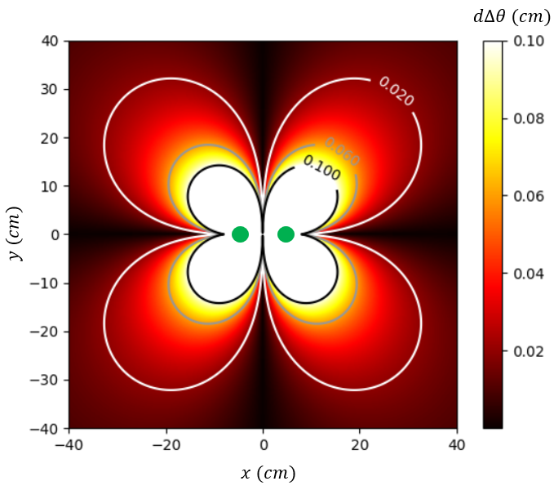

Fig. 15. Spatial resolution in cross-range direction with 1-cm accuracy of distance measurement. The green dots represent the two microphones fixed at (8,0) and (-8,0).

1. **Phase Compensation Subsystem**

Algorithm of Phase Compensation

As mentioned above, the slave SRPCubes must perform proper phase compensation on the received RF signal (*f*RF,com) to synthesize the array pattern of the SRPArray. Suppose that all the SRPCubes of a SRPArray are placed on the same plane, say x-y plane, and the desired main beam direction of the SRPArray is set at unit vector *vB*. Please notice that while only 2D array configuration is considered here, it should be easy to extend to 3D cases. The master SRPCube first transmits an RF signal (*f*RF,com) with phase *θm*, and one of the slave SRPCubes, denoted as S1, receives the signal with phase *θm*−*k*|*v*1|, where *k* is the free-space wavenumber of the RF signal and *v­*1 is the relative position vector from S1 to the master SRPCube. By positioning itself with the MAUP subsystem, the slave SRPCube (S1) can then perform proper phase compensation *θp*1 on the received signal and re-radiate the compensated signal with one of its patch antennas, which is determined in prior according to the array configuration.

According to the array theory, the phase of the re-radiated signal of S1 needed should be

|  |  |  |
| --- | --- | --- |
|  |  | (12). |

Since the phase of the received signal of S1 is *θm*−*k*|*v*1|, the compensation phase *θp*1 should be

|  |  |  |
| --- | --- | --- |
|  |  | (13). |

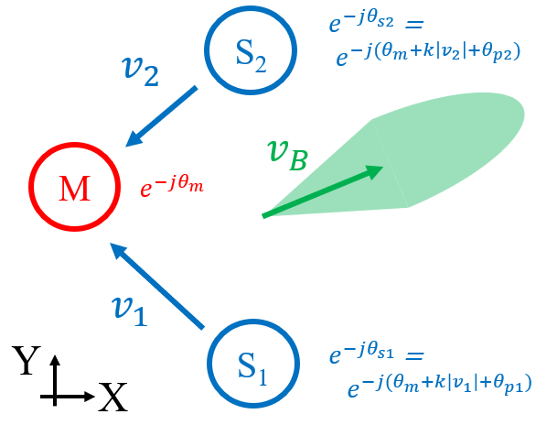

Fig. 16. Illustration of the relative positions of the SRPCubes and phases of the RFsignals (*f*RF,com) when positioning. The red and blue circles represent respectively the master SRPCube and two slave SRPCubes. ***v*1** and ***v*2** are the unit vectors of the relative positions from the slave SRPCubes to the master SRPCube. The master SRPCube transmits an RF signal (*f*RF,com) with phase *θm*, and the salve SRPCubes re-radiates the signal with phases *θ*S1 and *θ*S2. The semi-transparent green area indicates that the main beam synthesized by S1 and S2 aims at ***vB*** direction.

Phase Compensation Measurement

Here, we propose a simple experimental setup, as depicted in Fig. 17, for testing the performance of phase compensation of SRPCubes. A master SRPCube and a slave SRPCube are placed face to face along a motorized sliding rail, which is used to quantitatively simulate the movement in range direction of the SRPCubes, or drones, in flight. The RF signal (*f*RF,com) is generated from Port 1 of a vector network analyzer (VNA), and radiated by the master SRPCube. The slave SRPCube receives the signal, performs proper phase compensation after acquiring its relative position from the master SRPCube, and then transfers the phase-compensated RF signal directly to Port 2 of the VNA. If the phase compensation subsystem functions properly, the phase of the measured S21 should be independent of the position and vibration of SRPCubes. This experiment could not only help us predict the performance of SRPArray but also identify the bottleneck of the entire system so that we may refine the design and improve it.

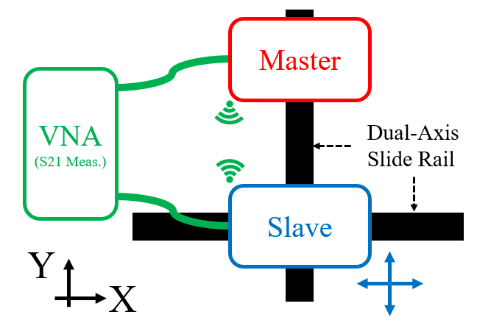Fig. 17. Proposed experimental setup for testing the phase compensation performance of SRPCubes. The dual-axis sliding rail placed under the slave SRPCube provides quantifiable movement on x-y plane for characterizing the performance of phase compensation.

1. **Radiation Patterns of SRPArray**

Simulation method

To predict the performance of an SRPArray before really launching the SRPCubes, we developed SRPSim, a ray-tracing-based python code. The simulation model considered in SRPSim is illustrated in Fig. 18. By importing the 3D radiation pattern of the patch antenna element, which was obtained from Ansys HFSS simulation, and accounting for the predicted movement of SRPCubes in flight, the spatial resolution of the MAUP module, and the phase compensation subsystem, the radiation pattern that would be synthesized by the SRPArray in real application scenarios could be predicted. Based on the current results, SRPSim has proved that the algorithm proposed in Section II is effective in maintaining the gain in the desired main beam direction despite of the mutually uncorrelated Gaussian random displacement error applied to the SRPCubes.

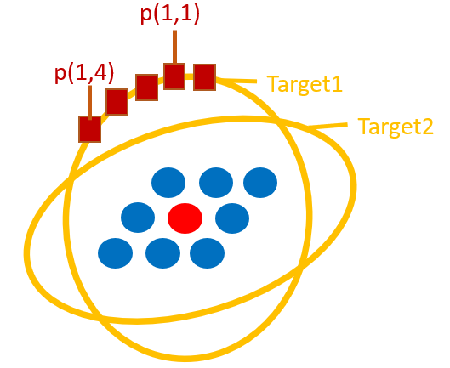

Fig. 18. Illustration of the SRPArray model considered in our in-house ray-tracing-based python code for calculating the radiation pattern that would be synthesized by the SRPArray. The red circle represents the master SRPCube, the blue circles represent the slave SRPCubes, and the yellow ellipses stand for the far-field observation circles on different planar cuts of interest, on which the far-field radiation patterns are calculated. Please notice that the spatial arrangement of the SRPCubes and the number of SRPCubes in use are subject to change. The radiation pattern is obtained simply by summing up all the phase-compensated RFsignals re-radiated from the salve SRPCubes to the far-field observation points (brown squares) distributed along the yellow ellipses.

As an exemplary demonstration, we calculated the gain patterns of a four-element linear array, which is aligned with the x-axis, composed of isotropic point sources, operating at 3.5 GHz, and equally spaced with 0.5*λ*0 (43 mm). For all four point sources being static and fed with equal phase and amplitude, the ideal radiation pattern should look like the green solid line in Fig. 19. By individually adding Gaussian random displacement with a fixed standard deviation (*σ* = 0.1*λ*0, 0.2*λ*0, and 0.5*λ*0) on the x-y plane to each point source’s location, the radiation pattern would deviate from the ideal one. Taking the root-mean-square (RMS) of the amplitude deviation of the pattern and adding/subtracting it from the ideal pattern, we may obtain the upper and lower limits of the radiation pattern, shown as the red and blue dashed lines in Fig. 19, respectively. One could observe that the RMS error of the pattern increases as the standard deviation of the point sources’ displacement increases.

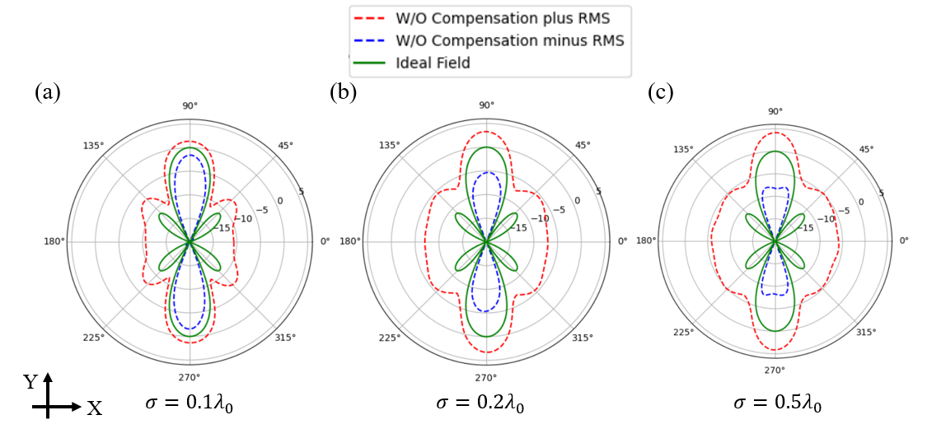

Fig. 19. Without applying the phase compensation, the ideal gain pattern, ideal gain pattern plus the RMS gain deviation, and ideal gain pattern minus the RMS gain deviation. The RMS gain deviation is obtained by applying Gaussian random displacement to the isotropic point sources 100 times with standard deviation of (a) 0.1*λ*0, (b) 0.2*λ*0, and (c) 0.5*λ*0. As one may expect, as the standard deviation of displacement increases, the gain deviation increases as well.

The efficacy of the proposed phase compensation algorithm could be observed in Fig. 20. By applying the same displacement error mentioned above along with the phase compensation algorithm, the peak gain of the main beam is kept almost unchanged as in the ideal gain pattern, while the gain variation in the other directions still increases as the standard deviation of displacement increases. Therefore, it is proved that the phase compensation algorithm is effective in maintaining the quality of communication in the main beam direction. Further investigation is needed to assess the phase compensation subsystem.

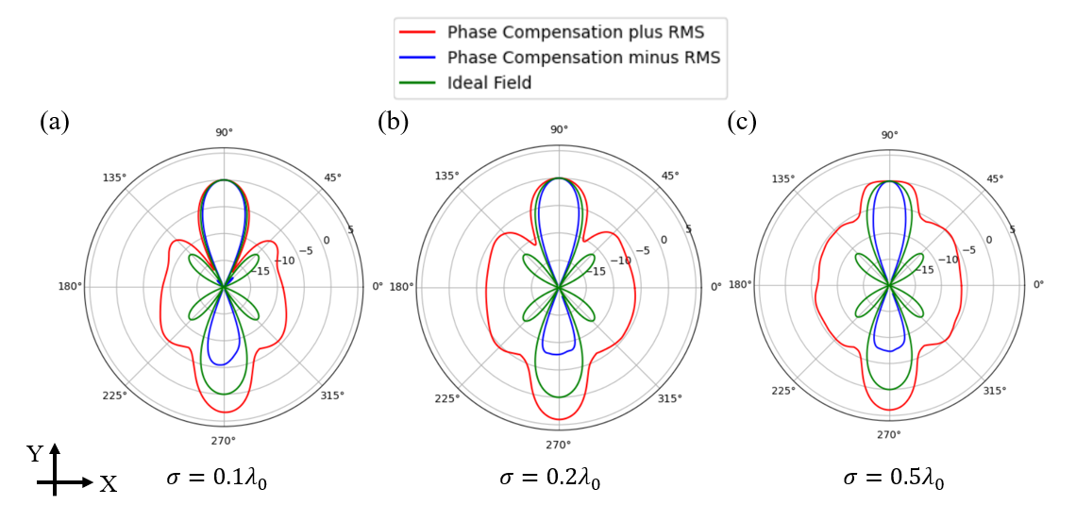

Fig. 20. By applying the phase compensation, the ideal gain pattern, ideal gain pattern plus the RMS gain deviation, and ideal gain pattern minus the RMS gain deviation. The RMS gain deviation is obtained by applying Gaussian random displacement to the isotropic point sources 100 times with standard deviation of (a) 0.1*λ*0, (b) 0.2*λ*0, and (c) 0.5*λ*0. We could observe that the gain of the main beam maximum is kept consistent with that of the ideal radiation pattern despite of the displacement error.

Static Measurement

The static radiation pattern is the far-field pattern produced by the SRPArray without any physical movement. It could be measured by traditional far-field or near-field methods in microwave anechoic chambers. By combining multiple motorized sliding rails as shown in Fig. 17, the synthesized beam patterns of the SRPArray in different array configurations, though static, can be fully characterized by the spherical near-field measurement system at the National Taiwan University.

Dynamic Measurement

In order to take into account the physical movement of SRPCubes in real application scenarios and measure the radiation patterns synthesized by the SRPArray, one possible solution is to hybridize the antenna measurement system with an optical motion-capture system, which is illustrated in Fig. 21. Referencing to the brochure of Sports 3DMA provided by STT Systems, the optical motion-capture system could readily capture the motion of targets with 2-mm accuracy and 100-Hz update rate, which is far enough for characterizing the performance of SRPArray.

The proposed hybridization of antenna measurement with optical motion-capture system is illustrated in Fig. 22. In addition to the ordinary setup of optical motion-capture system, an array of RF power meters is placed on the ground and below the flying SRPArray under test. With each power meter sensing the received RF power level at *f*RF,com and the optical motion-capture system monitoring the movements of the SRPCubes simultaneously, we could record both the motion and the synthesized pattern of the SRPArray under test with enough spatial and time resolution. The collected data could then help characterize and improve the performance of the proposed SRPArray.

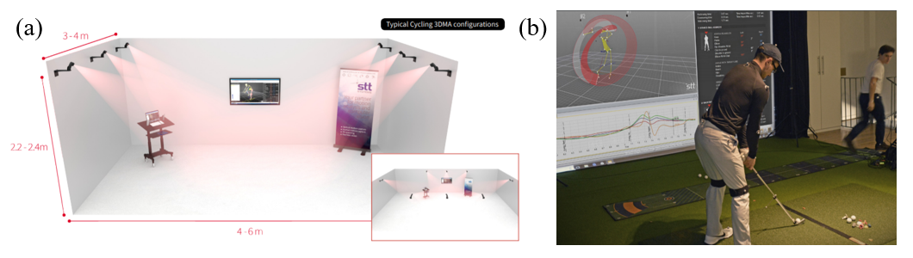

Fig. 21. (a) A reference setup of the optical motion-capture system, Sports 3DMA, offered by STT Systems. (b) Photograph of working scenario, in which the target-to-be-measured is labeled with multiple tags traced by surrounding cameras. (<https://www.stt-systems.com/downloads/sports-3dma/STT_Sports3DMA-E-2018.pdf>).

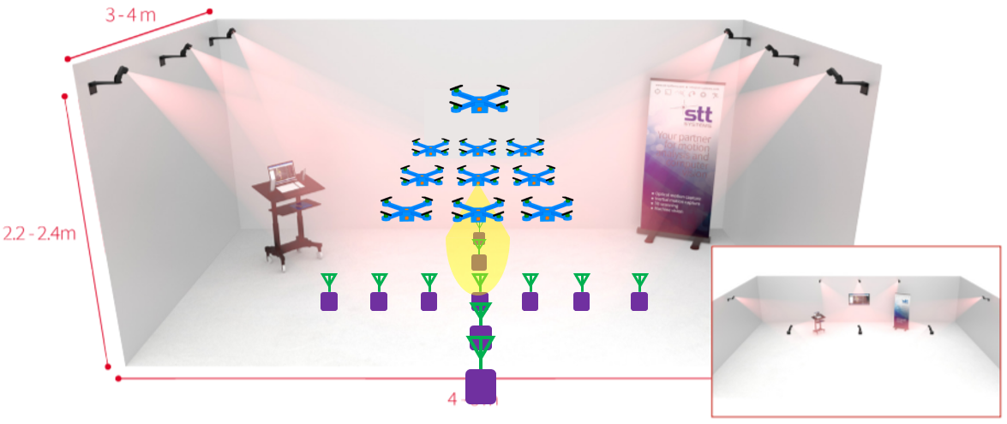

Fig. 22. One possible setup of the hybridized antenna measurement and optical motion-capture system. The motion of the SRPCubes are captured by the surrounding cameras (black boxes on the walls) and the synthesized array pattern is measured by the RF power meters (purple rectangles) connected with antennas (colored in green). The power meters will be connected with microcontroller or computer for post processing.

1. 預期完成之工作項目及成果。請分年列述：1.預期完成之工作項目。2.對於參與之工作人員，預期可獲之訓練。3.預期完成之研究成果（如實務應用績效、期刊論文、研討會論文、專書、技術報告、專利或技術移轉等質與量之預期成果）。4.學術研究、國家發展及其他應用方面預期之貢獻。

The Gantt chart for the development of the SRPArray in this three-year research project is shown below. In the first year, we will focus on the improvement of the 1D positioning subsystem and development of 2D positioning subsystem. In the second year, we will implement the phase compensation subsystem and integrate it with the 2D positioning subsystem. Besides, the performance of the phase compensation subsystem will be tested, and the radiation patterns produced by the preliminary prototype of SRPArray that works in simplified 2D scenarios will also be measured and compared with those calculated by SRPSim. Lastly, in the third year, the 3D positioning subsystem will be implemented and integrated with the phase compensation subsystem, other circuitries, and the drones. The performance of the entire SRPArray will be tested, under both static and dynamic operational conditions. The detailed task plans for the three-year period are given below.

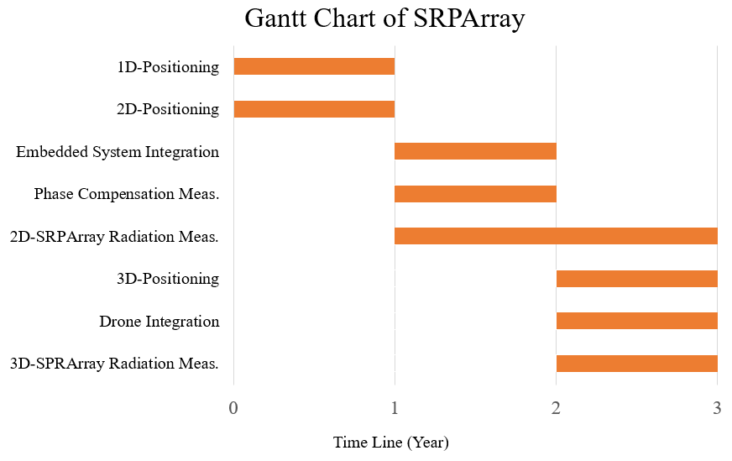

1. First Year: Positioning Subsystem from 1D to 2D
   1. Improve the positioning accuracy of MAUP for 1D positioning.
   2. Develop the circuit module and algorithm of MAUP for 2D positioning.
   3. Test the performance and reliability of the 2D positioning subsystem both inside and outside the anechoic chamber.
   4. Complete and augment the SRPSim code and then use it to calculate the radiation patterns that would be synthesized and generated by SRPArray.
2. Second Year: Phase Compensation Subsystem and System Integration
   1. Integrate the MAUP circuit module, RF circuitries, embedded system module, and the drones.
   2. Implement the phase compensation algorithm and the associated circuit module.
   3. Test the performance of the phase compensation subsystem.
   4. Test the phase compensation performance of multiple SRPCubes working in simplified 2D scenarios.
   5. Measure the “static” radiation patterns produced by the SRPArray when working in different simplified 2D scenarios.
3. Third Year: Scanning SRPArray in Flight
   1. Extend and modify the 2D positioning MAUP circuit module for 3D positioning.
   2. Include Doppler effect into the MAUP algorithm.
   3. Integrate the 3D positioning subsystem and control software with the SRPCubes.
   4. Refine the design: reduce the weight, size, and power consumption of the circuits on SRPCubes.
   5. Test the scanning capability of the SRPArray in “static” environment.
   6. Setup the hybrid measurement system for “dynamic” radiation pattern measurement of SRPArray.
   7. Measure the “dynamic” radiation patterns of the SRPArray in flight.
4. Educational Values

Students who get involved in this research project will learn the following skills:

* Design, implementation, and characterization of phased arrays
* Embedded antenna design for drones
* Antenna measurement
* Development and verification of 1D, 2D, and 3D positioning techniques
* RF circuit integration and PCB-based system assembly
* Use of micro-controllers, such as R-pi, for different automation applications.

1. Possible Publication

With the project being granted, a few key topics in this project may find publishable in the associated renowned journals of IEEE as listed below:

* 1. IEEE Transactions on Antennas and Propagation or IEEE Antennas and Wireless Propagation Letters (novel type of antenna array, hybrid beamforming/scanning array, embedded antenna design for UAVs could be the candidate topics).
  2. IEEE Transactions on Instrumentation and Measurement or IEEE Internet of Things Journal (indoor positioning, UAV communication system, UAV-assisted wireless charging, and distributed transmit beamforming could be the candidate topics).

1. Contribution

The proposed SRPArray is capable of dynamically reconfiguring the spatial arrangement of the drone (or SRPCube) array and performing electronic beam scanning. It can thus be used in a wide variety of wireless communication, remote sensing, and radar applications. Some exemplary applications are listed in the following.

* 1. Air-to-Ground (AtG) Communication system

AtG communication is one of the major trends of future communication system. With high spatially-reconfigurability, SRPArray may guarantee the ubiquity and reliability of the AtG communication service despite of the blockage of buildings or terrains.

* 1. Ground-Penetrating Radar System

Limited by the capacity of current quadcopters and the size of the antenna array, the existing UAV-based ground-penetrating radar system could hardly scan the targeted region using beamforming or beam-scanning techniques. Therefore, the speed of scanning is limited by the flying speed of the UAVs. The SRPArray provides an opportunity to realize electronic beam scanning with UAVs separately carries one single antenna element or a small subarray.

* 1. High-Mobility Radar System

Traditional high-gain antenna array is bulky with significant RCS and could be easily targeted and located. SRPArray could be rapidly deployed/un-depolyed and adapt to the harsh requirements in the battlefield.

* 1. Non-planar or 3D Antenna Array

SRPArray provides a platform for non-planar or 3D deployment of the antenna elements, providing more possibility of the beam-forming, beam-scanning, or hybrid techniques.